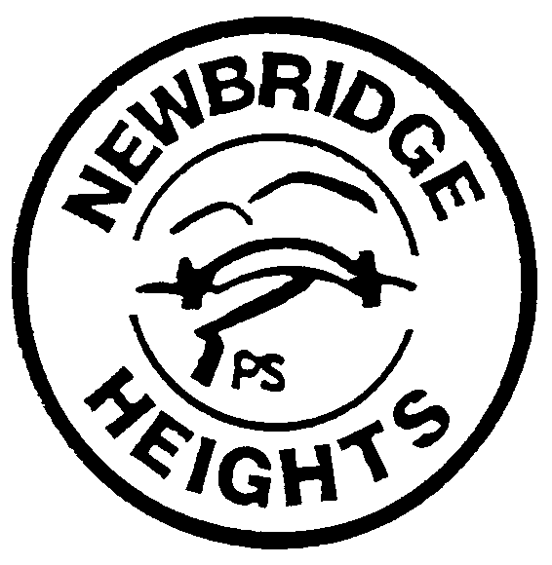

Newbridge Heights Public School July 2017

SCHOOL RULES
RULE | This means:
Be in the right place at the right time. | - Attend every school day, unless they are legally excused, and be in class on time and prepared to learn.  - Promptly move to lines and classrooms.  - Not play in “out of bounds” areas, eg: car parks, toilets, classrooms, and corridors.
Show pride in yourself and in your school. | - Wear correct school uniform with pride at all times.  - Maintain a neat appearance, including adhering to the requirements of the school’s uniform or dress code policy.
Always follow the teacher’s instructions.  (Always do what the teacher tells you to do.) | - At all times show good manners and behaviour towards visitors, teachers and peers.  - Not display disruptive and inappropriate behaviour such as calling out, answering back and interfering with others or the property of others.  - Follow teachers’ directions whether in the classroom or playground.  - Behave safely, considerately and responsibly, including when travelling to and from school.  - Show respect at all times for teachers, other school staff and helpers, including following class rules, speaking courteously and cooperating with instructions and learning activities.
Always show respect for others. | - Show respect for and understanding of the differences of others, including racial, physical and learning difficulties.  - Show respect at all times for teachers, other school staff and helpers, including following class rules, speaking courteously and cooperating with instructions and learning activities.  - Treat one another with dignity and respect.
Look after the school and its environment. | - Look after school and class materials, furniture, library books, textbooks, workbooks and the school environment.  - Care for property belonging to themselves, the school and others.
Behave safely, considering others. | - Not play dangerous games such as “branding, kicking and fighting”.  - Not commit any acts of physical or verbal violence, eg: hitting, spitting, swearing, tripping, bullying or other forms of harassment.  - Demonstrate appropriate behaviour towards animals. This means not causing pain or suffering to any animal by tormenting, kicking etc whilst at school or on school excursions.  - Behaviour that infringes on the safety of others, such as harassment, bullying and illegal or anti-social behaviour of any kind, will not be tolerated.

